OFFICIAL COORDINATION REQUEST FOR
NON-ROUTINE OPERATIONS AND MAINTENANCE

COORDINATION TITLE- 15TDA11 Ice and trash sluiceway closure
COORDINATION DATE- 10/8/15
PROJECT- The Dalles Lock and Dam
RESPONSE DATE- 10/15/15

Description of the problem: The tarp covering the ice and trash sluiceway needs to be replaced because it has large tears and is wearing fast. The tarp was originally installed with the sluiceway running. Because of the force of the updraft, six members of the structural crew were unexpectedly in hazardous conditions and were barely able to attach it. Due to these safety issues, the project would like to shut down the Ice and Trash sluiceway for 30 minutes to install the tarp properly.

Type of outage required: Closing the end gate of the ice and trash sluiceway

Impact on facility operation: No passage of fish or debris when the end gate is shut

Dates of impacts/repairs: Any time between 10/19-30/15

Length of time for repairs: 30 minutes

Expected impacts on fish passage: Peak passage for sub-yearling smolts was in late June/ early July and we are at the tail end of the passage season. Although the smolt monitoring program at John Day Dam has ended their season already, Bonneville SMP has reported an index range of 0-83 smolts per day for last week. Any fish that enter the sluice gates in this time frame would have to wait until the gate reopens.

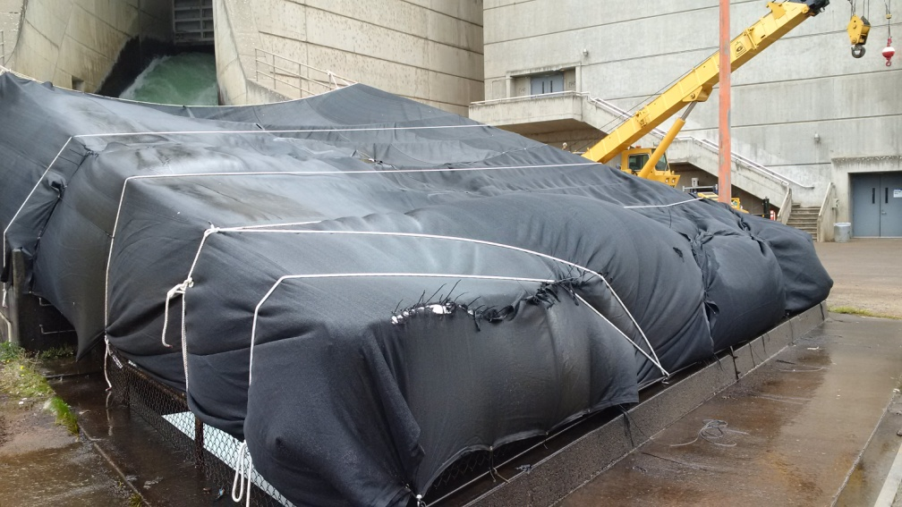
Comments from agencies

Final results

Please email or call with questions or concerns.
Thank you,
Karrie

Karrie Gibbons
NWP Operations Division Fishery Section
Columbia River Coordination Biologist
503-779-6131
Karrie.M.Gibbons@usace.army.mil

